Request for Criminal Record & Vulnerable Sector Check

To whom it may concern:

_____________________________ has offered to volunteer their time in the capacity of a
^{full name}
coach/manager/official/volunteer and/or staff for Athletics New Brunswick.

As recommended by the Coaching Association of Canada’s Responsible Coaching Movement and as approved by the board of directors for Athletics New Brunswick, all ANB coaches must provide a vulnerable sector check to ANB, not older than three years. ANB also recommends for all other volunteer members of our organization to provide a vulnerable sector check no older than three years.

This individual should be considered as a volunteer of a non-profit organization and will be working with children under the age of 18.

Once this vulnerable sector check is completed it is the individual’s responsibility to submit to the appropriate contact within Athletics New Brunswick.

We thank you for your assistance with this request. If anything further is required, please do not hesitate to contact us.

Sincerely,

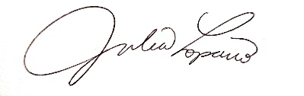
Julia Loparco
Executive Director
Athletics New Brunswick
anb@anb.ca
(506) 855-5003 (O)
Andrée Savoie
President
Athletics New Brunswick
andree@adelinproperties.com
(506) 874-8135 (C)
(506) 608-1175 (C)

